|  |
| --- |
|  |
| **Mrs. Thomas’ December Newsletter** |
|  |

Using Technology through Reading

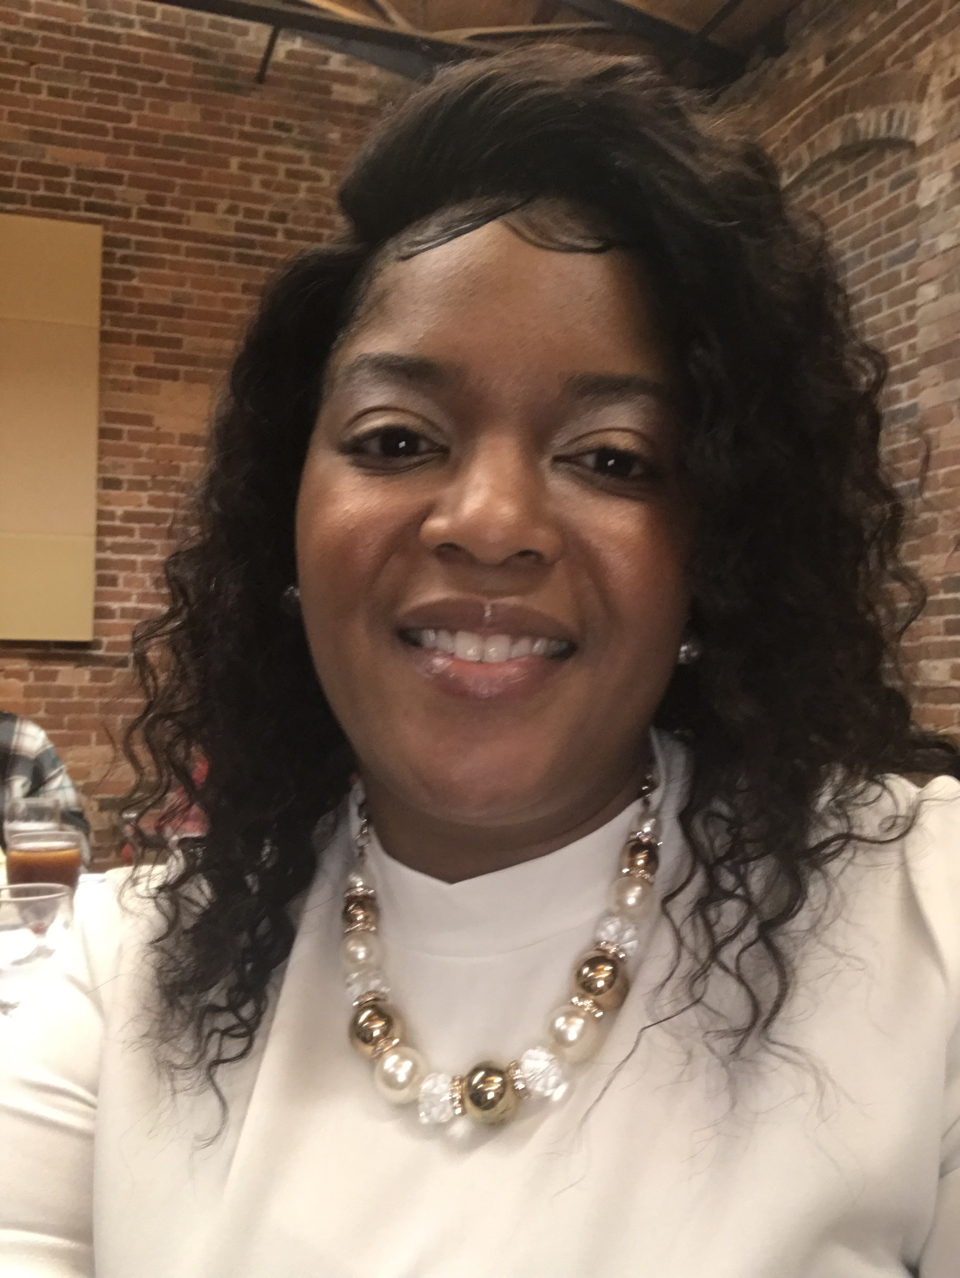

# Upcoming Events

## December 12

Reading Under the Stars with Principal Woodall @5:00 pm

## December 17

Title 1 Parent Meeting through Zoom. Link will be provided on teacher’s classroom page in Canvas

## December 22

Classroom Christmas Party@1:30pm

|  |
| --- |
|  |
| Important Announcement **Christmas Pictures-**  Students will be taking Christmas pictures. Make sure your child is at school on time to take their picture with their class. |

Email: [Thomas.shantina.r@muscogee.k12.ga.us](mailto:Thomas.shantina.r@muscogee.k12.ga.us)

[Sthomas7563@troy.edu](mailto:Sthomas7563@troy.edu)

Contact: (706) 566- 7345

Address: 2951 Martin Luther King Jr. Boulevard

Columbus, GA 31906

|  |
| --- |
|  |
| Dear Parents,  We are excited for the new project we will be working on. Our students are in the process of learning how to use technology to promote reading. If you are interested in taking part of the project contact me. If you know any sponsors who would like to contribute to our project, have them to contact our school. We are pushing to one-to one computers to be provided in our schools.  Also, Christmas is almost is here. We want to provide every student with a Christmas book. If you like to donate books to our school, it would be much appreciated. You will have until December 16th to get those books in. Thank you in advance for your hard work and support. |
|  |

**Student Collaboration**

Students will be collaborating together with their peers in school working on how to promote reading using technology. There are programs being provided to assist our student who are struggling in phonics and reading fluently. Students will also be learning how to write. Our students need help forming complete sentences using basic sight words. High school students will be volunteering to assist our students who are in 3rd through 5th grade. This opportunity will allow students to see the importance of reading and connect with other students. The high school students will be your child’s reading buddy.

**School Parents and Community**

We will need your help with enforcing the importance of reading. Our students are working on reading strategies and skills to promote reading and writing. Students need extra assistance from their teachers, parents, and community. We will need volunteers to assist our students to their fullest potential. If you would like to volunteer, there will be a sign-up sheet in the front office and one on your teacher’s Canvas page. Parents sign your name and time you will be available.

# This Week’s Assignments

**Reading/ELA-** Learning how to identify the problem within the story and finding the solution. Recount or retell the story to identify the lesson or moral in the story. Identify similes and synonyms.

**Writing-** Write informational writing using writing checklist and mentor text.

**Math-** Use distributive property of multiplication to break apart factor into smaller factors.

**Science-** Learning about rocks, soil and fossils.

**Social Studies-** Learning about Native Americans, locations, shelter, food, clothing, and culture.



|  |
| --- |
|  |
| In the CommunityChristmas Food Drive-Thru The school will be donating to families who are in need of a food box. There are families who are less fortunate. Our school will be giving out food boxes **Dec 22nd @9:00pm – 2:00pm** Christmas Book Donation If you would like to donate books to our students to have as a Christmas gift, please contact me through email and cell number. Information is provided above the newsletter. |

## 

**K. Colbert 12/13**